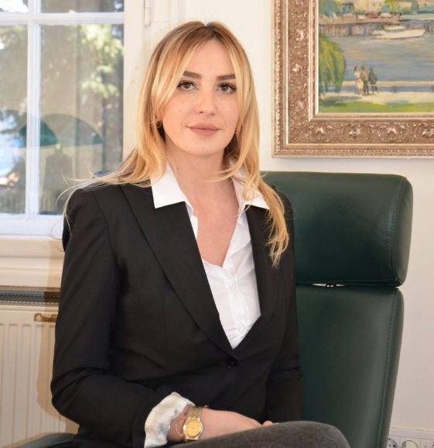

Mirjana Furundžić, LL.B.
Attorney at Law

PARIVODIĆ ADVOKATI / LAWYERS

Generala Vasića 1, 11000 Belgrade

Present work

Mirjana’s unique background and current work make her one of the most effective experts in Serbian corporate law. She heads the corporate team at Parivodic Advokati / Lawyers that incorporates and restructures all types of Serbian commercial companies (limited liability company d.o.o., joint stock company a.d., limited partnership k.d. and partnership o.a.), banks and insurance companies, investment funds and brokerages. She effects all registration changes within companies (change of directors, share capital, registered seat, line of business, articles of association, etc.) and implements them in the Company Register.

Mirjana structures, drafts documentation and closes all kinds of corporate transactions (mergers, demergers, acquisitions, spin-offs, sale of assets, etc.).

For buyers or sellers, we transfer shares in companies, structure joint venture agreements, public private partnerships, concession agreements, investment agreements with the state.

Professional
Experience

Mirjana worked full five years as assistant to Mr. Maglov, the chief registrar of the Serbian Business Registers Agency. She kept the register of companies, made decisions on incorporations, controlled documentation for incorporation and changes in companies. She approved filed documentation for all kinds of corporate combinations (like mergers, spinoffs, sale of shares, reduction/increase of share capital, liquidation and bankruptcy of companies, etc.). She coordinated cooperation with EU on improving the company registry.

Education / Qualifications
Bachelor of Laws (LL.B.) with specialism in International Law, Faculty of Law, University of Belgrade (2004-2009)

Belgrade Bar member since 2020

Proficient in English and Serbian languages

