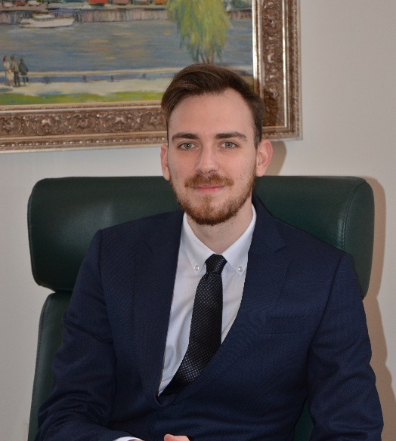

Associate

PARIVODIĆ ADVOKATI / LAWYERS

Generala Vasića 1, 11000 Beograd
mobile: +381 60 395 1223
email: petar.sutara@investmentserbia.com

Present work

Works intensely on projects practicing all labor law documentation, investment law, M&A transactions, IP law, drafting commercial agreements, all aspects of mining, construction law, real estate, environmental permitting, energy efficiency, infrastructure restitution, arbitration, company law.

Education / Qualifications
Bachelor of Laws (LL.B.) with specialism in International Law, Faculty of Laws, University of Belgrade (2014 – 2018)

Proficient in English and Serbian languages.

